THE SULO RIVIERA HOTEL
Address:
Matalino Road, Diliman, Quezon City, 1100, Philippines

Tel: (632) 924-5051
Fax: (632) 920-7030
info@sulorivierahotel.com

This prestigious Quezon City landmark is strategically located in the midst of the city's principal business and commercial hubs, as well as the headquarters of national government offices.
A stone's throw away from the Quezon Memorial Circle, the hotel is adjacent to the Quezon City Hall and the Heart Center for Asia.
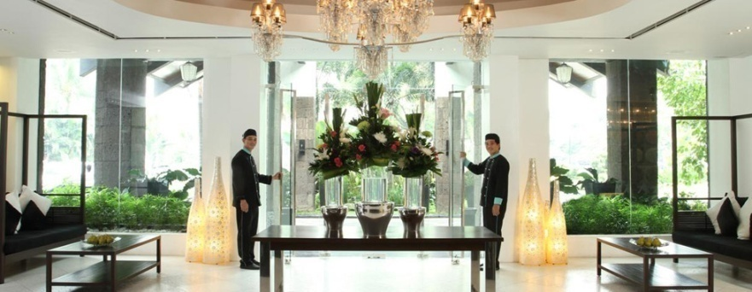

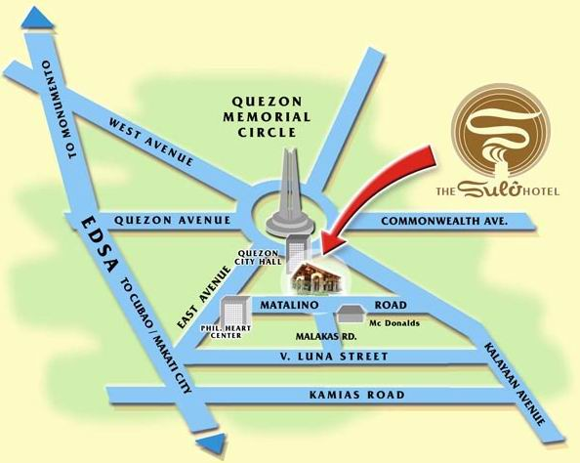
VENUE OF MEETING: -Travel Time from Sulo Riviera Hotel to venue (LTO) - 5 minutes

FERSAL HOTEL – MALAKAS, DILIMAN - Contact Information
# 131 Malakas Street, Diliman, Quezon City
Telephone No.: (632) 426-7308 / Facsimile: (632) 926-5140
Central Reservation: (632) 912-2691 & 912-8000/ Facsimile: (632) 912-2693
Email Address: reservations@fersalhotelgroup.com
Web Mail: www.fersalhotel.com

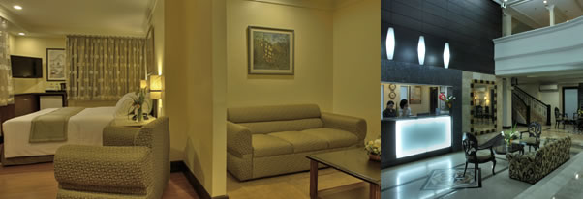
Among the most centrally located hotels in Quezon City, Metro Manila, Philippines, FERSAL Hotel – Malakas, Diliman knows what good positioning is all about.
Situated near many of the city’s most important sites, our hotel serves as a comfortable home for all your activities in this part of the metro. Here, you’ll appreciate our location close to government offices, business establishments, and commercial enterprises.
Aside from this valuable quality, our hotel also provides affordable accommodations and other features that tourists and business travelers will surely appreciate.For easy rest and relaxation, we've got cozy rooms fitted with air-conditioning, cable TV,private bathroom for each unit ,daily housekeeping and a mini-bar. Our excellent facilities, meanwhile, include conveniences such as a business center, travel agency, city transfer and 24 hour front desk.
Travel Time from Sulo Riviera Hotel to venue (LTO) - 5 minutes

Imperial Palace Suites Quezon City

Address
Timog Ave. Corner Tomas Morato Avenue, Quezon City, Philippines
Telephone: (632) 927-8001
Fax: (632) 920-7881/920-7884

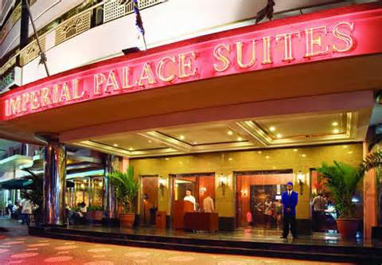

The Imperial Palace Suites in Quezon City is the preferred choice of residence for both business and leisure guests as it lies at the crossroads of all major centers of interest in the city known as the Philippines' shopping mecca--Quezon City.

This Manila hotel in Quezon City is just minutes walk from the GMA-MRT Station, which gives easy access to several mega shopping centers - SM City complex, SM Mega Mall, the Robinsons, the new Gateway & ShopWise Shopping Complexes and the newest Ayala shopping complex, Trinoma. Its location is also known as a restaurant row and "the" dining village of Manila's in-crowd.

MAP

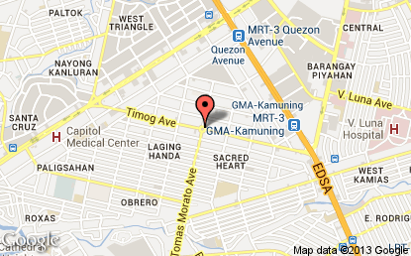
VENUE OF MEETING: -Travel Time from Imperial Palace to Venue (LTO) - 5 minutes
Imperial Palace Suites

