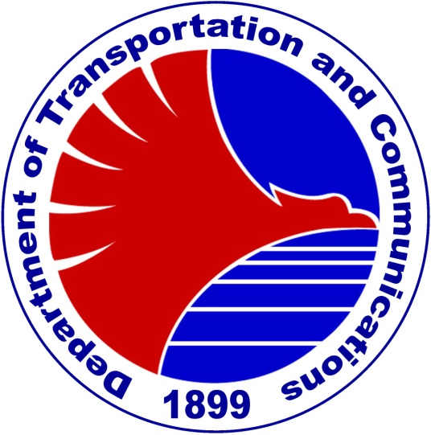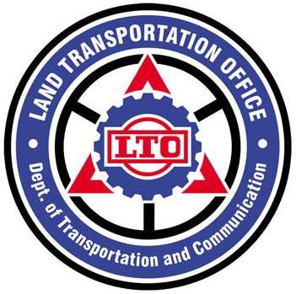

Attachment 1
Department of Transportation and Communications
LAND TRANSPORTATION OFFICE

3rd Public and Private Joint Forum in Asian Region
17th JASIC ASIA Government / Industry Meeting
December 4-6, 2012, Manila-Philippines

MEETING REGISTRATION FORM

Please type or print clearly, and e-mail to heriberta_domingo@yahoo.com or fax to +632-921-9069 before end of October 2012.
PLEASE USE CAPITAL LETTERS
……………………………………………………………………………………………………………

Participant Information

1. NAME_____________________________________________________________________
(FIRST NAME) (MIDDLE NAME) (LAST NAME)
- What should we call you? Mr. / Ms. ___________________________________________
2. ORGANIZATION/COMPANY __________________________________________________
3. POSITION & ORGANIZATION _________________________________________________
4. MAILING ADDRESS _________________________________________________________
5. COUNTRY / ECONOMY ________________________________________________________
6-1. TELEPHONE ________________________ 6-2. FACSIMILE _____________________
7. E-MAIL ___________________________

Function Attendance Information

Welcome Reception hosted by LTO (December 4, Tuesday evening) Yes ( ) No ( )
Farewell Reception hosted by JASIC (December 5, Wednesday evening) Yes ( ) No ( )
Technical Tour (December 6) Yes ( ) No ( )

