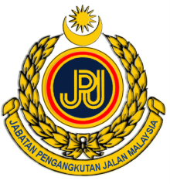

JASIC ASIA EXPERT MEETING ON VEHICLE CRASH (UNECE R94 & R95)
October 6-7, 2011, Melaka, Malaysia

MEETING REGISTRATION FORM

Please type or print clearly, and e-mail to diana.hanif@jpj.gov.my by September 20, 2011.

PLEASE USE CAPITAL LETTERS
……………………………………………………………………………………………………………

Participant Information

1. NAME: .
(FIRST NAME) (MIDDLE NAME) (LAST NAME)
* What should we call you? : Mr./Ms .
2. Economy: .
3. Organization: .
4. Position & Department: .
5. Mailing Address: .
.
6-1. Telephone: 6-2. Facsimile: .
7. E-mail:
……………………………………………………………………………………………………………

Function Attendance Information

Technical Seminar (6 October 2011) Yes ( ) No ( )
Technical Tour (7 October 2011) Yes ( ) No ( )

